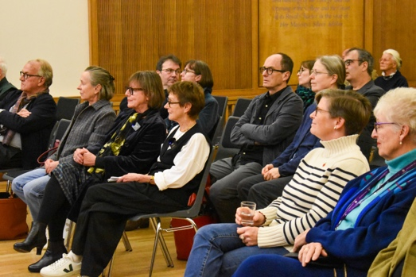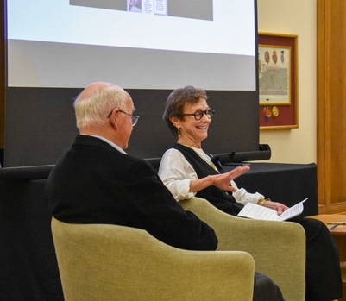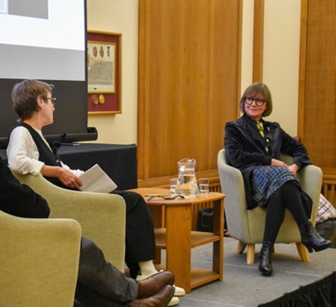

NICCI GERRARD IN CONVERSATION WITH PAULINE TERREEHORST ABOUT ‘SECRETS OF A SUITCASE’ (Hurst Publishers, London), WOLFSON COLLEGE CAMBRIDGE 1.11.2024

*Pauline Terreehorst*: It’s wonderful to be back in Wolfson, where I was a Press Fellow many years ago. Thank you, John Naughton for the kind invitation to present the English translation of my book in these impressive surroundings. I would like to start with a short introduction to *Secrets of a Suitcase*. Afterwards you can join Nicci Gerrard and me in our conversation.

-----------------------------------------------------------------------------------------------------------------

Each life is the sum of many stories – some of them could even be told just concentrating on the objects you carry with you, and those you surround yourself with. For instance: if somebody would forget his or her bag after this event, or even better: if a stranger would accidentally visit your study, and would see all these little personal objects you keep on your desk, the souvenirs, photographs and books, the tickets, the old chair, the plaid - some nice stories could be told about your style, your background, your history. I am not sure I can do that, but Nicci Gerrard surely would be able to do so.

I wrote about left luggage indeed: about a vintage Gucci suitcase from the sixties, that ended up at Sotheby’s Amsterdam in 2004. It was filled with objects and memories which I could connect to the life of an impressive woman: Countess Margarethe Szapáry-Henckel von Donnersmarck who lived and worked in the Lungau, a remote part of Austria, under Salzburg, in the first half of the 20th century. I sketched her life from her youth in Silesia, her wedding to a poor Hungarian count in 1900, and her encounter with Hermann Göring in the 1930’s - all the way up to the wedding of her granddaughter Yvonne Szapáry in the Hague in 1966 to the German prince Karl von Hessen, a nephew of the late Duke of Edinburgh.

Two fairytale marriages. What happened in between? What kind of decisions were made by these women? Were they ‘of their time’? Did they remain the agents, the architects of their own lives? Or did they become ‘circumstantial collaborators’, as the German philosopher Peter Sloterdijk once put it? It is up to you when you read my book.

Reflecting on their lives, this inevitably will lead to what we ourselves are doing in these complicated times. Is it enough to write books, or opinionated articles in papers, blogs or magazines, in order to warn other sensible people for what is happening around us? What can we learn from histories like these in preventing the new fascist-styled leaders of our time who ruin the lives of ordinary people, their countries, and reign as dictators over a polluted world? I am aware that these are big questions, but in the end, that is why I decided to write down what I found after I stumbled upon a Gucci suitcase.

*Nicci Gerrard*: There is something irresistibly poignant in a suitcase travelling through Eastern Europe isn’t it. Sean [French] is here and he said it reminded him of Stefan Zweig’s ‘The World We’ve Lost’. Your suitcase is like a metaphor for that. I have various questions I would like to ask. You wrote a book about things. It is stuffed with things. Not only big things, like a castle or a bed, but little things that you associate with women, like little crucifixes they carry around. And it is also about the changing borders of all these countries there, that were shifting all the time. But I want to start with a simple question. It never occurred to me that you could haunt auctions to buy suitcases. Do you do this a lot?

PT: No, actually it was a side dish. I was looking for furniture for our new house, when I stumbled upon this suitcase at Sotheby’s. I was the director of the Amsterdam Fashion Institute at that moment, and I admired the craftmanship of Italian brands like Gucci and Prada that were quite popular at the time. I just liked this suitcase.

NC: It was not about the things that were inside? It was just a lucky dip?

PT: Yes, a lucky dip indeed.

NC: Apparently you can buy suitcases that are left in airports, where you don’t know what you’re getting. It was not like that?

PT: I assure you, I have not made a habit of it. This was the first and the last time.

NC: Your biography shows that you are more often interested in things, fashion and objects. What is that?

PT: As I said earlier, things, objects, are part of your life. They show who you are, they are part of your history. It is important to have them near you, to create a nice surrounding, they are part of you. Not to display your wealth, but because all these objects have their own meaning.

NC: There is a kind of history hold in things, isn’t it?

PT: Yes. My mother died just before this book was launched in the Netherlands. I had the experience myself, to decide what was important for me, to keep her alive. These are often little things of minor value. The things you keep also reflect your ideas. It is not only your head that’s important, it is also everything you surround yourself with.

NC: If you had bought a Gucci-suitcase with a different life told through the objects, could you also have written about that, or was it this particular suitcase, these particular photographs?

PT: I could write the book only because I found all these extraordinary stories in it. It was the wealth of history that I found. I knew very little about what had happened in Silesia. Because Silesia, for us, that’s where Auschwitz was, it is not a place that you identify with beautiful palaces. It was fascinating to find out how many palaces were there, which are all destroyed now. If you think about everything that disappeared in Silesia, that’s enormous.

NC: Another thing that struck me when reading your book, is that you use a lot of qualifying phrases like: ‘just imagine that..’, ‘I think that..’ – you found facts and you had to join up the dots, isn’t it, to make the story. So is it *the* story of her life, or is it just one way of looking at the life of this particular woman living in that century?

PT: It is my story of this particular woman, living alone, trying to be a good neighbor for the people that surrounded her. I like to stress that. I could have stressed a lot of other things. Like what happened to her family, her granddaughter marrying this Prince von Hessen, coming from a nazi-family. I did not do that. I wanted to focus on her life, from the beginning till the end.

NC: When you were done with researching, at what point did you think: this is a book? And what was the moment of surprise, what was the moment that took your breath away and kept you going on?

PT: There were a few moments, actually. The first was the connection with the life of Göring. I think even a lot of historians do not know how important Castle Mauterndorf has been for Göring. That he built up his envy, his grudge against people ‘having it all’ from a very young age. In the end he became one of the biggest thieves of the Third Reich crowd. The other moment was when I discovered that Margarethe’s family may have had a reputation problem, which caused her to marry late, at 29. Her uncle was married to one of the most famous *grandes horizontales* of Paris. Finally I wanted to know what happened to the furniture. That became clear much later, in 2016, when the auction results of Weinmüller were published on the web.

NC: Can you describe her as a woman, more than ‘married at 29’ and being a philanthropist?

PT: She was a tough cookie I think. She was also quite strict for the people around her. She gave money, a lot, but you had to do something for it. Sometimes she will not have made friends. But she had to be strict to help the region. When you go there now, you will see a lot of eco-farming and eco-tourism. She started that in a way.

NC: Indeed, she is extraordinary. She started off with no experience, going to this unheated castle. There she is, having these two children, becoming a widow, then comes the war, this terrible war, and she comes out on her own like an entrepreneur, like someone who runs a massive company. She seems to have had huge competence in herself having all these mathematical abilities. And then she experiences the gradual decline of all that, and of her whole family after her, and her whole class. She seems not incredibly sympathetic. She is a woman, on her own, a philanthropist. She is very explicitly against Hitler, she puts herself in a very vulnerable position being anti-Hitler. She is extremely courageous and stubborn, almost reckless at times, but her politics are not straightforwardly wonderful, and she is not so much anti Hitler. Is it correct to say that she does not support Hitler because of his beliefs, but because he wants to take her Austria?

PT: She is very nationalistic, she did not see that nationalism isn’t very helpful at that moment, and that her kind of nationalism, acting like a queen, doesn’t help either. It was different for authors like the Jewish writer Joseph Roth who defended European Austrian culture. She did not defend that culture.

NC: And even, though she was a very successful single woman, she was not a great defender of women’s rights either, was she?

PT: Only very late in life she gets sympathetic to women’s rights. She herself did what she wanted to do, on her own, because she had this role in the area where she lived. She lived quite on her own, in this respect.

NC: Did you like her? She seemed to me impressive, but not entirely sympathetic.

PT: I did not like her as a very nice woman, I think she was quite difficult from time to time. She was not very likeable. She had to behave like this to survive. But I appreciated that, I had respect for her. Women don’t always have to be likeable.

NC: I would so agree with that. But in the end, it is such a sad story, she did wonderful things, but it is a story with a bleak ending.

PT: Yes. But she tried.

NC: She tried, that is true. And hats off for you, writing about what happened to her in Central Europe. You must have done a phenomenal amount of research for that.

PT: Well, it took some time before I could write. But, while working on the book, I read and heard about wat was happening in Ukraine, again a region with a very complicated history. That kind of news drives you.

NC: Now, if I would acquire a suitcase in London, I can guess there are a lot of cosy things in there. But if you do that in Central Europe, it probably contains a lot more of uncomfortable stories.

PT: I bought it in Amsterdam, not in Berlin. And it was a suitcase of the sixties. I could not predict a connection with WWI and WWII.

NC: One final question, what would you think if someone bought a suitcase of yours and wrote a story about its contents?

PT: OMG, I hope I will be dead by then. But I get what you’re hinting at. I wrote about someone who does not live anymore. I would not have done it if she was still there. And the Gucci did not belong to her after all. It was from the sixties. You have to read my book for an explanation.

NC: In this book, you have put quite a lot of your own knowledge about things.

PT: You are right: I could not have written this in my 30’s. That’s one of the great things of old age.

**Q&A**

Q: Could you also have written about the history of the suitcase itself, where it came from, where it was stored in between, and how it ended up in Amsterdam?

A: I definitely knew that it came from one place, from one family. The dresses for instance had the same size. I could match all the other objects with members of this family. The year of the auction was also important. It was not long after the last surviving member of one generation died, and her house was sold.

Q: I myself work with things. Were they curated? Did someone selected them, were they important for somebody, or were they objects on a table that were shoved into a suitcase in haste?

A: No, more like some forgotten things in an attic that were put in a suitcase and some boxes.

Q: This is a story about objects. I can imagine some people deliberately get rid of some objects. Were there objects you missed while telling your story?

A: There was already a wealth of objects, I did not want to find more.

Q: Usually there are two types of collections. For instance: the nouveaux riches of the 19th century collected to create a background to link them to a past. Was her furniture collection a collection that was complete or was it built up?

A: She built it up herself. Coming from Silesia, she grew up in castles that were completely furnished in an eclectic French-Italian style. She deliberately chose for a medieval style. And this was extended to the comfort in the castle. There were only oil lamps, candles and wood stoves.

Q: Why didn’t she leave? It must also have been a depressing environment.

A: I think it functioned as a cloister for her, after her husband died. And I found that later on she only lived there in the summer. She also had a farm nearby, where she stayed in winter. The castle itself was loved by the English and Scottish women though, who visited in the summer as paying guests in the twenties and thirties.

Q: Do you know more about the English and Scottish women that travelled to such faraway places? And which effect had their visits on the public opinion?

A: I wished I knew more. What were they looking for? A gothic castle, pristine nature, or interesting conversations at a fireplace about politics? I hope to trace some of them now, with this English translation. But one of them certainly was Rosemary Murray, who visited her aunt Isabel DuCane from Sussex a close friend of Margarethe, and who wrote about her visit in her diary. Murray returned quite disturbed about what was going on in Germany.

Q: In clearing a house with the belongings of two generations myself, I felt I was intruding their privacy. Have you felt sometimes that you breached their privacy?

A: I had a similar experience with the belongings of my own mother, but not with this suitcase. Do not forget that this family auctioned it off themselves. In a way they opened up their own history. Of course you have to respect the privacy of others, but they themselves gave it away.

Q: You said that you described what happened between these two fairytale weddings. You put these two photos up. If you only had these two photos, and you know that between these photos their whole world was destroyed, do you think that the people in the second photo feel deeply connected to the first one? Would they have felt that there was a continuity? Did they feel that their world was lost?

A: Obviously the difference is striking. I think they still had the feeling they were part of this whole history. They all relied on their memories and imagination. There was not only this modest wedding in The Hague, but there was also a grandiose party in the former castle of the Hessen family near Frankfurt two days before. The castle was transformed into a golf-hotel in the fifties, but they used it in 1966 as a backdrop for their party. You see this also in the way they dressed up. They played being people of importance, a role. The only thing that was left for most of them was their imagination. And their impressive long names. They use these names, up until now, sometimes even in a troubling way.

Q: Nowadays we also see people with suitcases, fleeing. I wonder which contemporary resonance you felt when reproducing this story.

A: This was a comparably lucky woman. She could auction off her entire furniture herself. A lot of people you describe, do not have that choice. In a way she was lucky she could do it on her own terms. She did not flee with a suitcase. Many stories could be told about what is happening at the moment, based on suitcases, but they will be different. Margarethe Szapáry was not a victim of Göring, she was a victim of her time. The real victims at that moment lived elsewhere, the Jews in Vienna for example, from whom everything was stolen.

